Table of Contents

Chapter 1 - Setting Up Appium with Android on Windows 2

1. Install Node.js - Download and install Node.js from nodejs.org. 2

2. Download SDK Platform Tools 2

3. Install Appium and the UIAutomator2 Driver 2

4. Download Appium Inspector 2

5. Download Java JDK 22 2

6. Install Android Studio (optional) 2

7. Enable USB Debugging on Real Device 3

8. Customize Driver Settings for Android 3

Chapter 2 - Setup Appium with iOS on MacOS 4

1. Install Necessary Tools 4

2. Connect device to Xcode 6

3. Config WebDriverAgent 7

4. Run IOS Testsuite 15

5. Common Error 17

# - Setting Up Appium with Android on Windows

## Install Node.js - Download and install Node.js from [nodejs.org](https://nodejs.org/).

## Download SDK Platform Tools

* + Download at: <https://developer.android.com/tools/releases/platform-tools>
  + Set up the system environment variable ANDROID_HOME to point to your Android SDK installation.
  + Add %ANDROID_HOME% to your system Path environment variable.

## Install Appium and the UIAutomator2 Driver

* + Open your terminal or command prompt and run the following commands:

npm install -g appium  
appium driver install uiautomator2

## Download Appium Inspector

* + Use Appium Inspector to check app interfaces. Configure the app capabilities as follows:

{

"capabilities": {

"appium:automationName": "uiautomator2",

"platformName": "Android",

"deviceName": "emulator-5554",

"appium:appPackage": "com.android.settings",

"appium:appActivity": "com.android.settings.Settings",

"appium:noReset": "true"

}

}

* + To find the appPackage and appActivity, open the app on your phone and run the following commands in your command prompt or terminal:

adb shell  
dumpsys window | grep -E 'mCurrentFocus'

## Download Java JDK 22

* + Install JDK 22 from [AdoptOpenJDK](https://adoptium.net/) or the [Oracle website](https://www.oracle.com/java/technologies/javase-downloads.html).
  + Set the JAVA_HOME environment variable to the path of the JDK installation.
  + Add the JDK bin directory to your system Path.

## Install Android Studio (optional)

* + Skip this step if you are using real device, this step is to set up Android Emulator
  + Download and install Android Studio from [developer.android.com/studio](https://developer.android.com/studio).
  + Use Android Studio to set up and manage your Android Emulator.

## Enable USB Debugging on Real Device

## Customize Driver Settings for Android

Modify driver configurations in /resources/config/driverSettings.js:

android_local: {

settings: {

type: 'android',

webDriverUrl: 'http://localhost:4723',

webDriverPath: '/',

start: true,

httpConfig: {

readTimeout: 160000

},

webDriverSession: {

capabilities: {

"alwaysMatch": {

"platformName": "Android",

"appium:platformVersion": "14.0",

"appium:deviceName": "R5CTA2TV7NE",

"appium:automationName": "UiAutomator2",

"appium:appPackage": "com.android.settings",

"appium:appActivity": "com.android.settings.Settings",

"appium:connectHardwareKeyboard": true,

"appium:newCommandTimeout": 300,

"appium:noReset": false

},

"firstMatch": [{}]

}

}

}

}

# - Setup Appium with iOS on MacOS

## Install Necessary Tools

* 1. **Install Xcode**
* Choose the version based on your device’s iOS and macOS. Check [Apple’s guide](https://developer.apple.com/support/xcode) for details.
* Ensure Xcode is in the “Applications” folder. Use this command to check: xcode-select -p

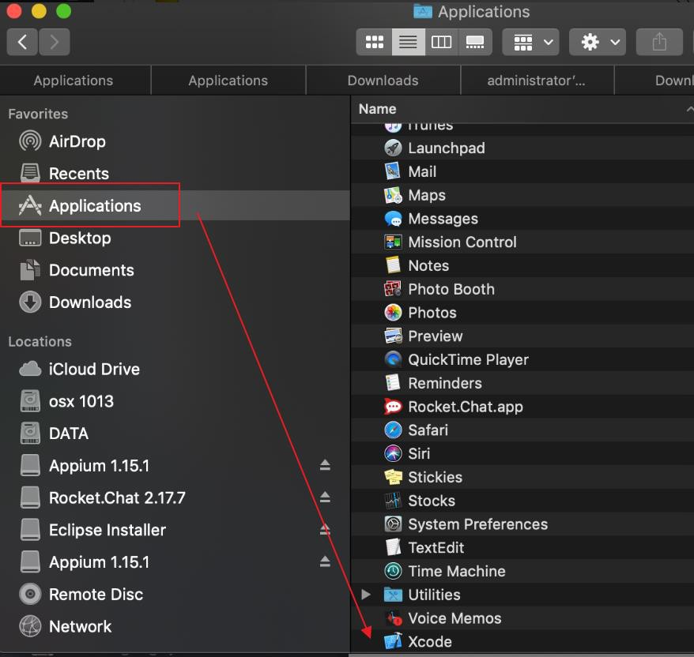

* If you installed Xcode by offline file you can drag and drop Xcode app into “Applications” folder
* If the path isn’t correct, set it:

sudo xcode-select -switch /Applications/Xcode.app/Contents/Developer

* 1. **Install brew**
* Run:

usr/bin/ruby -e "$(curl -fsSL <https://raw.githubusercontent.com/Homebrew/install/master/install>)"

* If there is permission error. Please add full permission for cmd tool by follow step in this link <https://osxdaily.com/2018/10/09/fix-operation-not-permitted-terminal-error-macos/>
* Or try this command line

sudo chown -R $(whoami) $(brew --prefix)/*

* 1. **Install node and npm**
* Get npm from [npmjs.com](https://www.npmjs.com/get-npm).
* Verify installation: [npm](https://www.npmjs.com/get-npm) –v

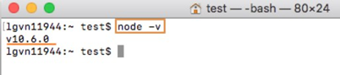

* 1. **Install maven**
* Run: brew install maven
* Check with: Run mvn -v

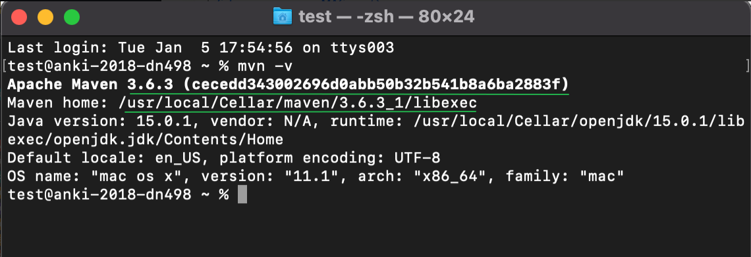

* 1. **Install Appium**
* Run: npm install -g appium

(refer <http://appium.io/>)

* 1. **Install XCUITest**
* Run: brew install libimobiledevice
  1. **Install Carthage**
* Run 2 command lines
  + - 1. brew install carthage
      2. brew install ios-deploy
  1. **Install ios-webkit-debug-proxy**
* Run: brew install ios-webkit-debug-proxy
  1. **Install appium-doctor**
* Run: npm install -g appium-doctor

If result same as image that mean, every above steps are correct. Make sure that Xocde is installed at: /Application.Xcode.app/Contents/Developer and Xcode Command Line Tools path is the same image too.

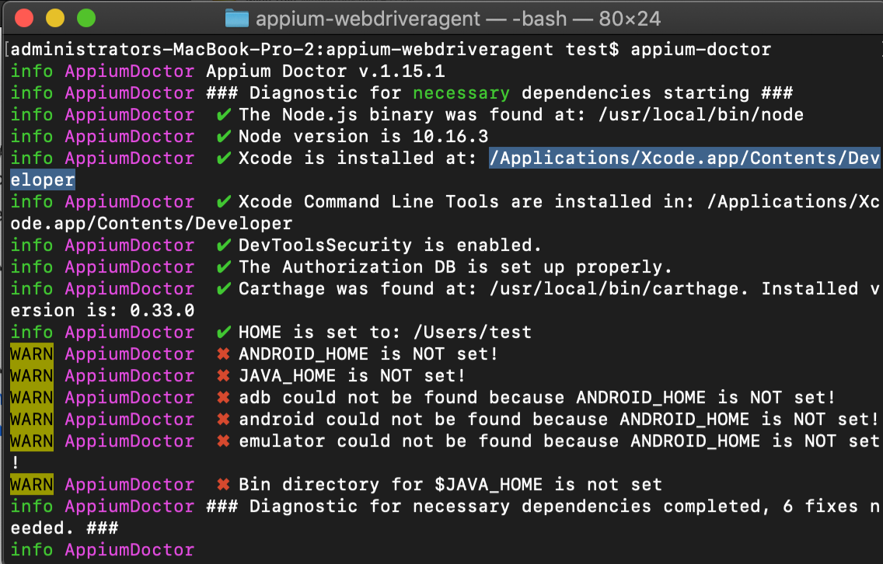

## Connect device to Xcode

* 1. **Real device**
* Connect your device to Macbook by cab
* Go to Xcode > Window > Device and simulator > tab Devices
* If there is your device information that mean your device is connected successfully

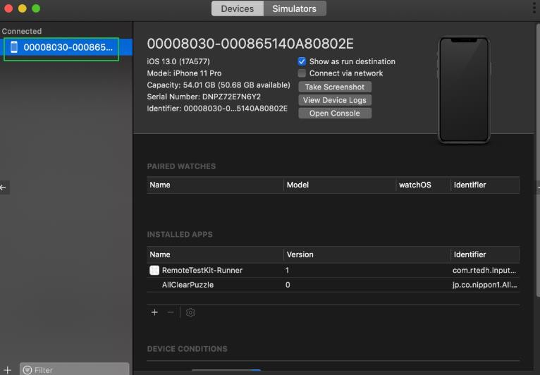

* 1. **RTE**
* Rent iphone
* Click icon Xcode connector
* Input macbook password and wait for successful message display

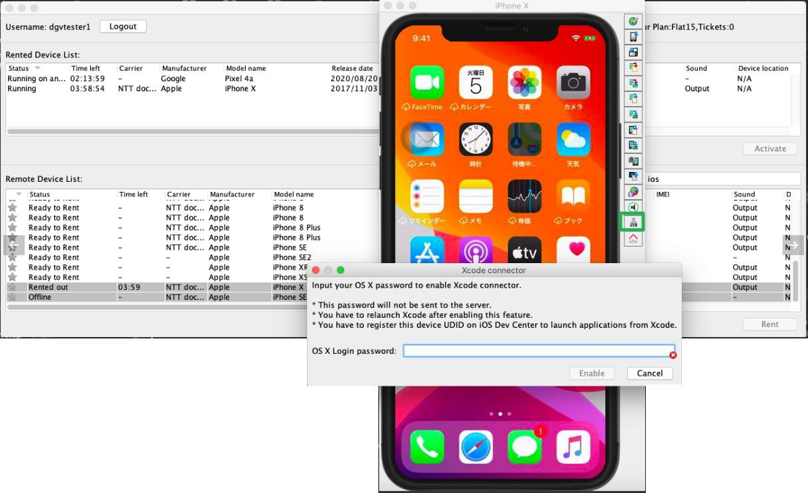

* Open Xcode (close and reopen if Xcode is running)
* Go to Xcode > Window > Device and simulator > tab Devices
* Wait for device information display (about 5 minutes)

## Config WebDriverAgent

* Find location of WebDriverAgent.xcodeproj by this command

echo "$(dirname "$(find "$HOME/.appium" -name WebDriverAgent.xcodeproj)")"

* Navigate to appium by:

+ Right click on Finder, select “go to folder”

+ Enter the location get from previous steps

* Inside folder /appium-webdriveragent/, open “webdriveragent.xcodeproj”

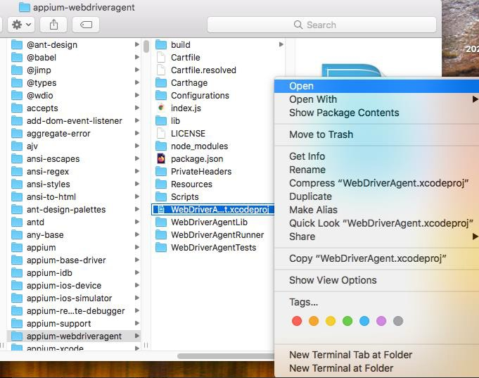

* Sign in with an apple developer account and select Team
* If the Bundle Identifier fails, you can change the name of the bundle, because the bundle ID is unique. If someone has already taken the ID, you’ll need to change it.

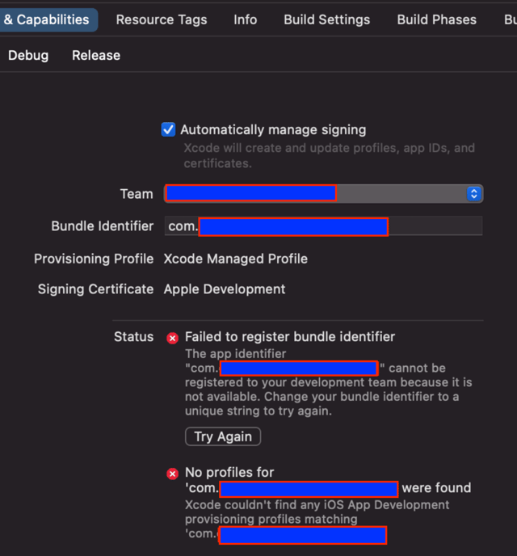

* Select WebDriverAgentLib:
  + - Select target connected device in “2. Connect device to Xcode”
    - Check Automatically Manage signing checkbox
    - Select a team
    - On menu-bar: select Product-> Build

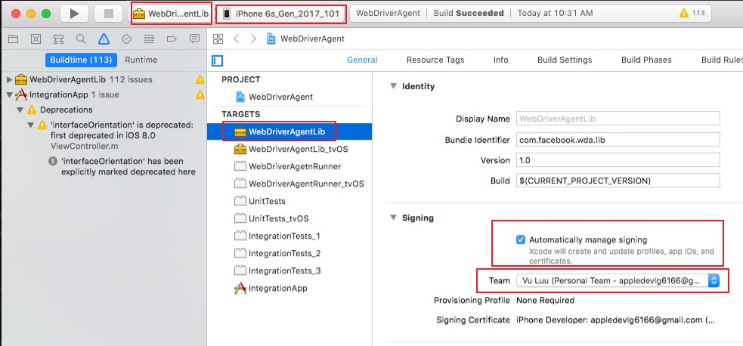

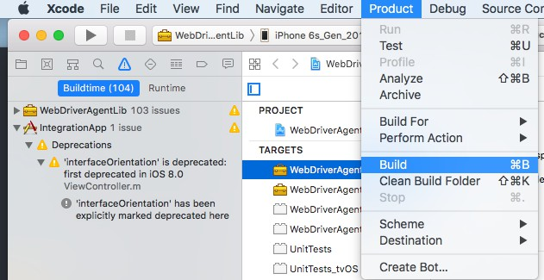

* Select IntegrationApp:
  + - Select target device
    - Check Automatically Manage signing checkbox
    - Select a team
    - On menu-bar: select Product-> Build

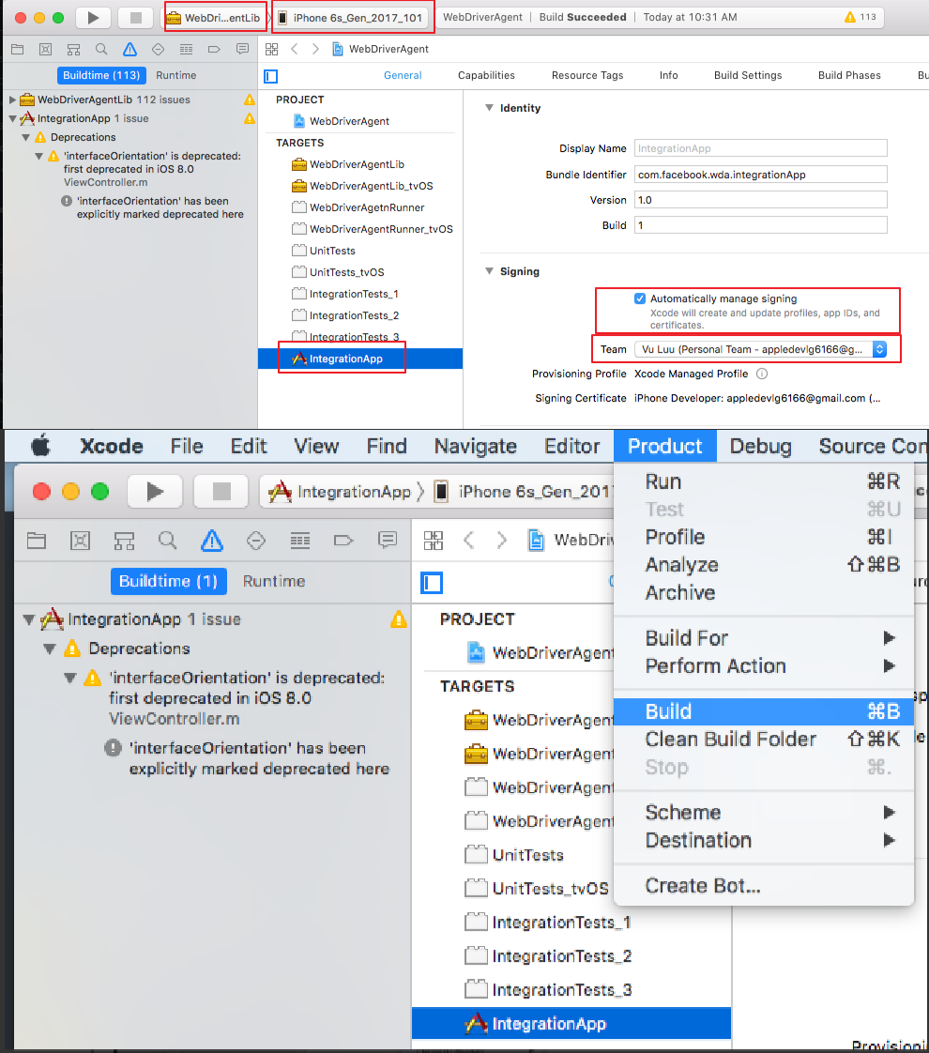

* Select WebDriverAgentRunner:
  + - Select target device
    - Check Automatically Manage signing checkbox
    - Select a team
    - On menu-bar: select Product-> Build

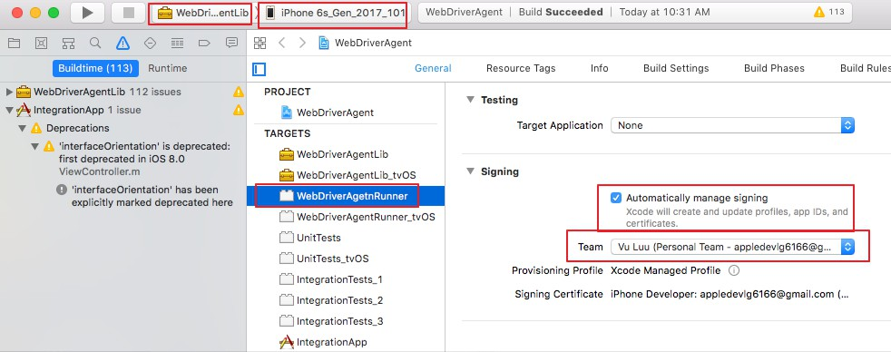

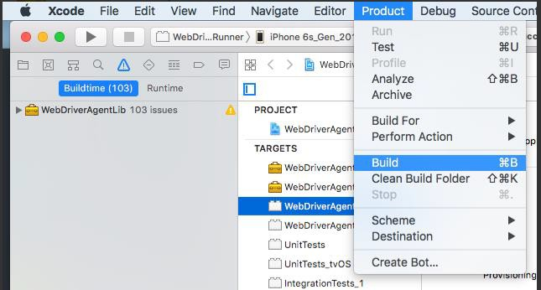

* Install WebDriverAgent to device:
  + - Select Produce -> Scheme and change to WebDriverAgentRunner
    - On menu-bar: select Product -> Test

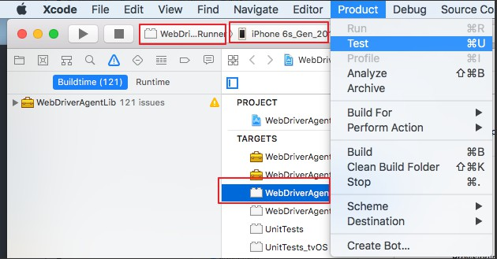

* After Install successful, an error message like below image will be displayed. **Don’t worry You are doing it right**

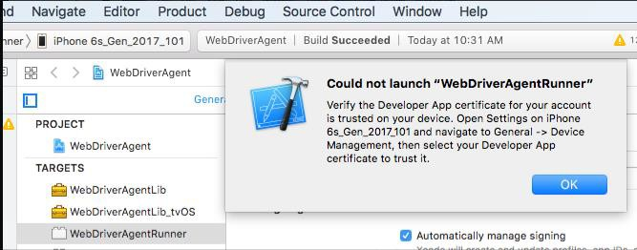

* Check and make sure WebdriverArgentis installed on device

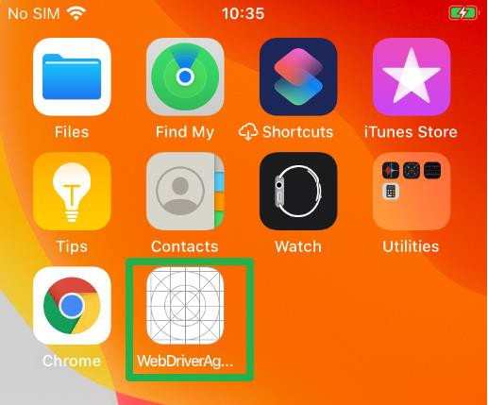

* Next step you should trust WebdriverAgent: On device navigate to General > Device Management Then select WebdriverAgent and tap Trust button

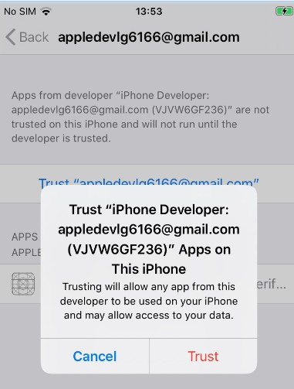

* Enable these settings on device:
* Enable Settings > Privacy & Security > Developer Mode
* Enable Settings > Developer > Enable UI Automation
* Enable Setting > Safari > Advanced > Web Inspector
* Get device uidi: xcrun xctrace list devices
* Create appium session to make sure that everything is OK.
  + - Download Appium Inspector (<https://github.com/appium/appium-inspector/releases>)
    - Capabilities

{

“platformName”: ”iOS”,

“appium:deviceName”: ”iPhone”,

“appium:platformVersion”: “16.6”,

“appium:udid”: “<device udid>“,

“appium:automationName”: ”XCUITest”,

“browserName”: “Safari”

}

* Start appium server using command line: appium

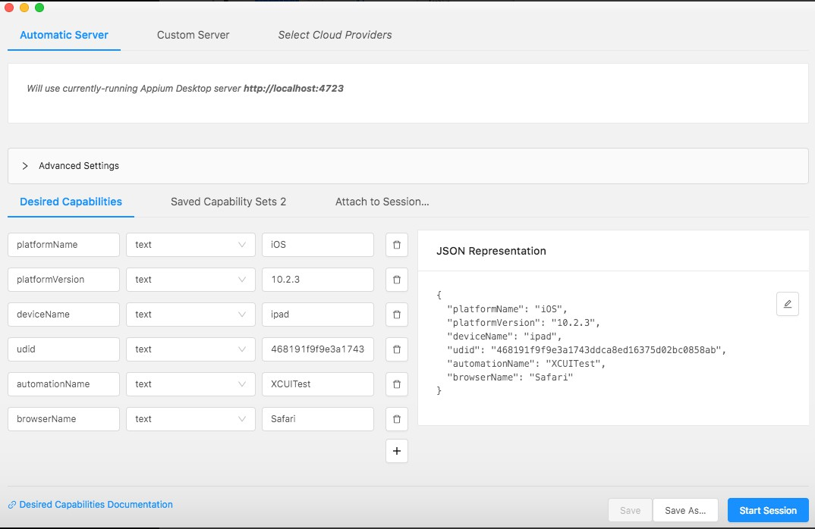

* If session is created successful, that mean you setup environment successful.

## Run IOS Testsuite

* Update udid
* Open file [Project path]\src\test\resources\browsers.setting.properties
* Change udid of [iosdemo.native] to your udid that collected from “2. Connect device to Xcode”

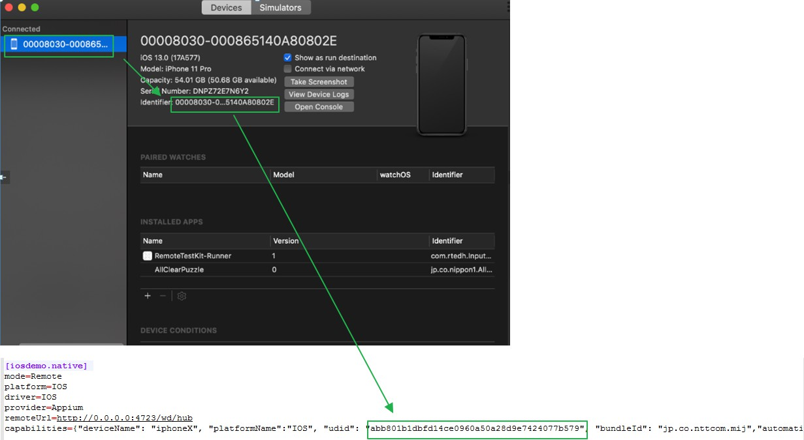

* Make sure that WebdriverAgent is installed if not please check "2. Config WebDriverAgent" for more detail. Notice that WebdriverAgent will be expired for 7 days (free apple account) so you should reinstall it in next week.
* Open finder app in macbook
* Navigate to project folder
* Right click to project folder
* Select “New Terminal at folder”

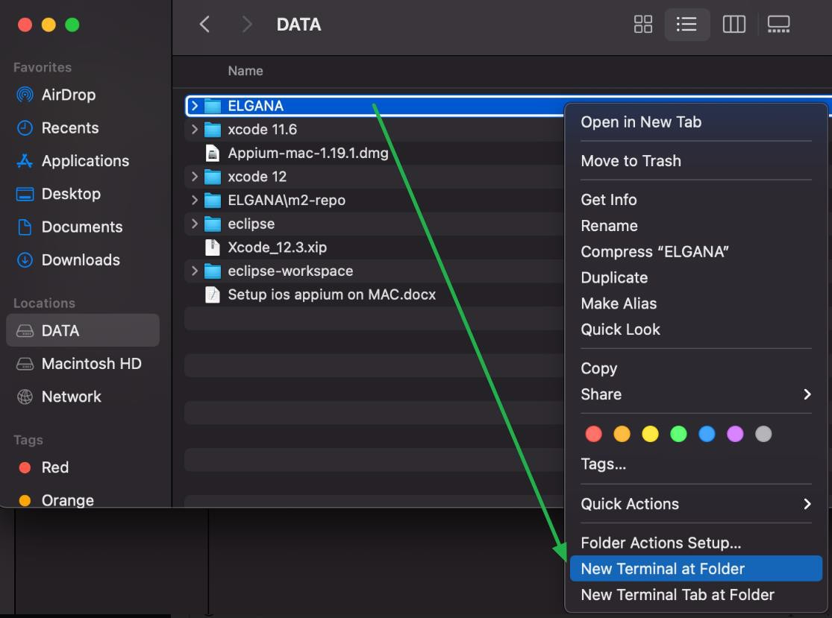

* Run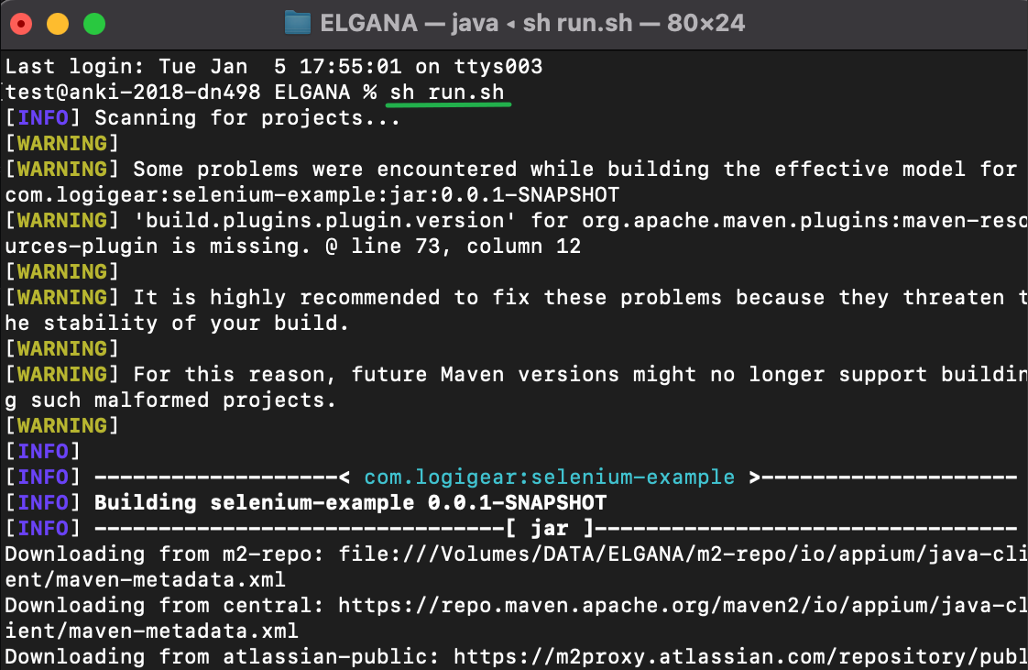: sh run.sh
* Go to [project path]/test-output to check report

## Common Error

* 1. **Sudo command not found**
* Run command:

export PATH=/usr/bin:/usr/sbin:/bin:/usr/local/bin:/sbin:/opt/x11/bin:$PATH

* 1. **Can’t open “webdriveragent.xcodeproj” due to xcode compatibility version**
* Right click “webdriveragent.xcodeproj” and select “Show package contents”
* 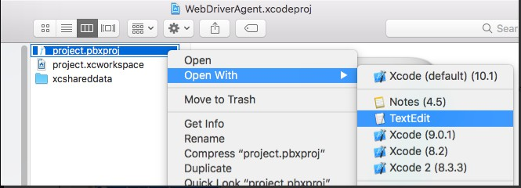Open project.pbxproj with TextEdit
* Edit objectVersion following below info
  + For Xcode 10.0

objectVersion: 51

* + For Xcode 9.3:

objectVersion: 50

* + For Xcode 8.0-9.2:

objectVersion: 48

* + For Xcode 6.3-7.3.1:

objectVersion: 47

* 1. **Could not locate device support files.**
* Please follow this link to fix it: <https://github.com/filsv/iPhoneOSDeviceSupport>
  1. **Failed to created Provisioning Profile**

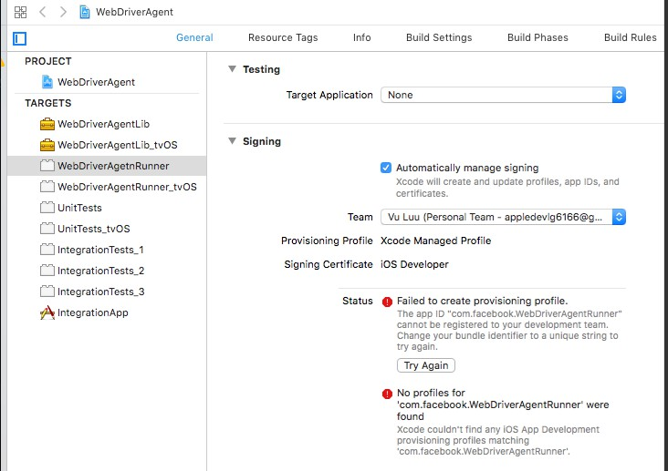

* Go to “Build Settings” tab
* 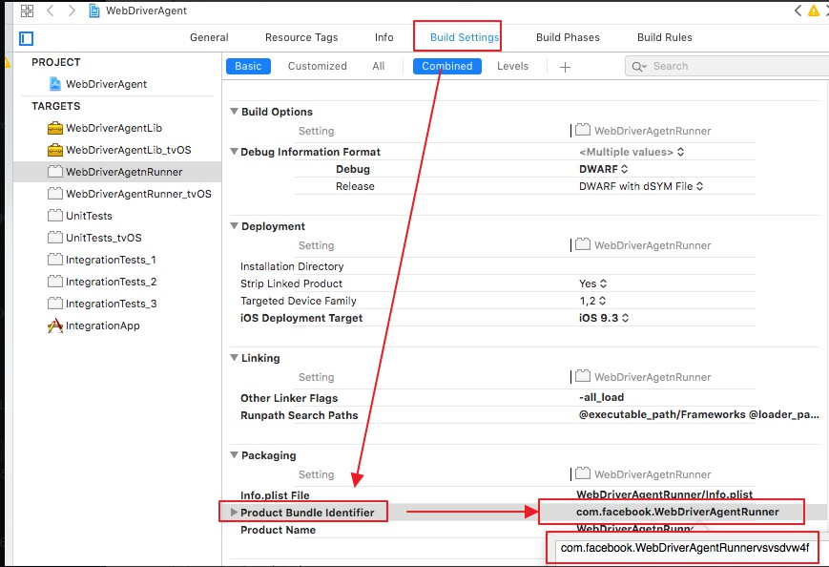Add random text to “Product Bundle Identifier”
* 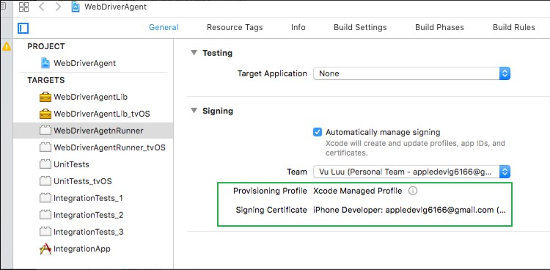Return General tab and wait xcode accept. If not try to change “Product Bundle Identifier” again